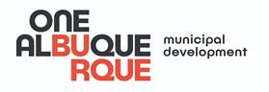 | FOR IMMEDIATE RELEASE  Contact: Johnny Chandler | 505-331-7729  June 6, 2020

Mayor Keller’s Vision Zero Team Asking Community for Input on Active Streets and Safe Streets
New Active Streets Initiative and Safe Streets Pledge creating safer roadways
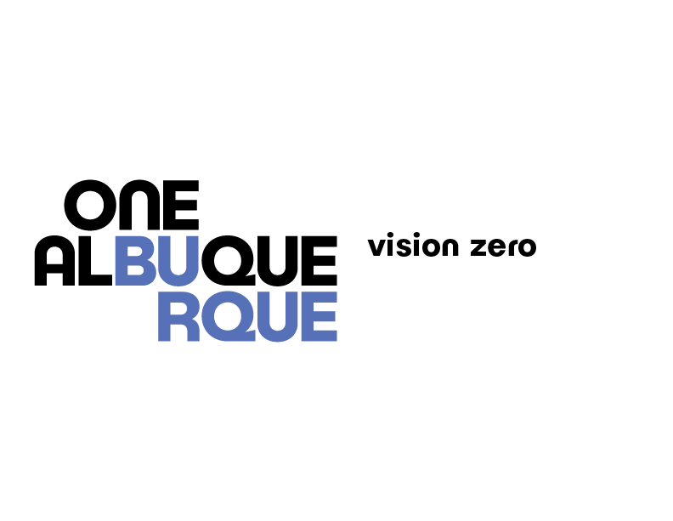
ALBUQUERQUE, N.M. – Mayor Tim Keller and the City of Albuquerque Vision Zero Task Force are asking the community for input on two initiatives to make our streets safer for all users. The Active Streets initiative will convert streets that fit the criteria into pedestrian, skateboard, and bicycle friendly zones that bring people together in safe, socially-distanced ways for recreation, dining and other uses. The Safe Streets Pledge asks residents to help take ownership for using streets in ways that are safe for vehicles, pedestrians, and cyclists alike. Mayor Keller is asking the community to take the pledge, and to help identify potential Active Streets as part of our City’s commitment to Vision Zero.
“As we re-open the city we are reminding residents to take care of each other on our roads and sidewalks by taking the pledge to make our streets safer. We’re also looking for new ways to use streets as ways to bring people out of their vehicles and into the community where it makes sense to do so,” said Mayor Tim Keller. He added, “We need you to play a direct role in helping make sure our streets are vibrant, safe, and community-driven.”

On June 1, 2020, Albuquerque City Council adopted a resolution to create an Active Streets Initiative in Albuquerque (R-20-59). The goal of this initiative is to facilitate safe, socially-distanced outdoor recreation and active transportation opportunities on neighborhood streets during the COVID-19 public health emergency. The Resolution directs City staff to identify an initial set of roadways to convert to Active Streets within two weeks. The Vision Zero Task Force will help guide the identification of these streets to ensure that Active Streets in Albuquerque help provide safe and equitable access to outdoor spaces for exercise, recreation, and safe community interaction. The choice of streets will consider community support, equitable distribution, transit service, type of roadway, and access to homes and businesses.

The Vision Zero Task Force has also launched the Albuquerque Safe Streets Pledge, which asks all Albuquerque residents, no matter how they get around, to pledge to use our streets safely.

The City encourages all roadway users to pledge to:
- Slow Down and follow speed limits.
- Respect and be aware of other roadway users, particularly people walking and biking.
- Stop at crosswalks, stop signs and red lights.
- Put down my phone and avoid other distractions while driving
- Never drive under the influence of alcohol or drugs
- Obey the rules of the road.

Mayor Keller signed an Executive Order committing Albuquerque to work toward the goal of zero traffic deaths by 2040.
Nominate an Active Street here for consideration by City staff. Take the Albuquerque Safe Streets Pledge yourself here and learn more about the City of Albuquerque’s commitment to Vision Zero by visiting cabq.gov/vision-zero.

###

Vision Zero is a commitment to create safer streets for all, whether walking, biking, driving or taking transit, and regardless of age or ability. It is used around the world to eliminate all traffic fatalities and severe injuries, while increasing safe, healthy, equitable mobility for all.

